# Random Float in Python

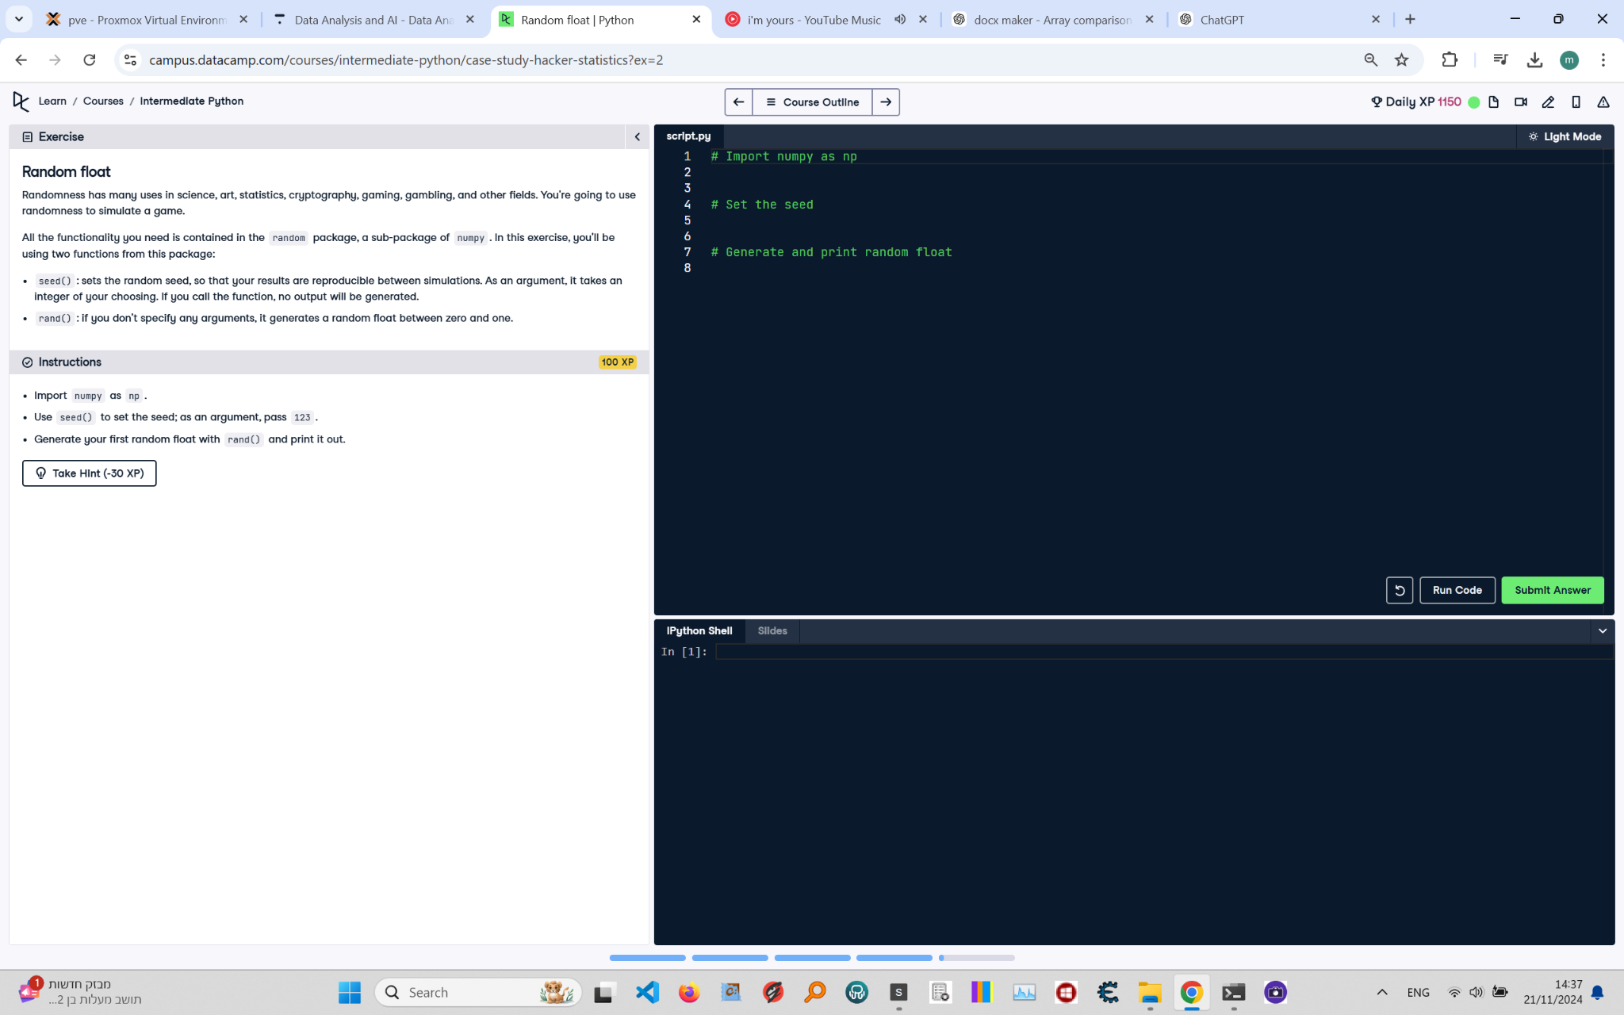

**Question:**

Randomness has many uses in science, art, statistics, cryptography, gaming, gambling, and other fields. You're going to use randomness to simulate a game.  
  
All the functionality you need is contained in the `random` package, a sub-package of `numpy`. In this exercise, you'll be using two functions from this package:  
- `seed()`: sets the random seed so that your results are reproducible between simulations. As an argument, it takes an integer of your choosing; if you call the function, no output will be generated.  
- `rand()`: if you don't specify any arguments, it generates a random float between zero and one.  
  
**Instructions:**  
1. Import `numpy` as `np`.  
2. Use `seed()` to set the seed; as an argument, pass `123`.  
3. Generate your first random float with `rand()` and print it out.

**Answer:**

Here is the Python code that solves the problem:

# Import numpy  
import numpy as np  
  
# Set the random seed  
np.random.seed(123)  
  
# Generate and print random float  
random_float = np.random.rand()  
print(random_float)

**Explanation:**

1. **Importing numpy**: The `numpy` library is imported as `np`, allowing you to use its functions with the alias `np`.  
2. **Setting the random seed**: The `np.random.seed()` function ensures reproducibility of the random number generation. Passing `123` as the argument initializes the random number generator to a fixed state.  
3. **Generating a random float**: The `np.random.rand()` function generates a random float uniformly distributed between 0 and 1.  
4. **Printing the result**: The generated random float is stored in the variable `random_float` and printed to the console.